CROUCH EVENT CENTER
900 E. GLENDALE ST.
CROWLEY, TX. 76036
FOR INFO PLEASE CALL
817.297.5170
Today’s Date | Renter’s Last Name |  |  | Renter’s First Name
Address |  | City |  |  | Zip
Phone Number |  |  | Alt. Phone Number
Email |  |  | Alternate Responsible Party

EVENT DETAILS FOR CROUCH EVENT CENTER
(All rental requests must be made at least 14 days in advance. Deposit due when room is reserved, balance is due 10 days prior to event.)
Event Date: ___________________
Purpose of event rental: ________________________________________
Will this be a youth event: Yes or No
Number of guests expected: _________________ (Maximum Building Occupancy 172)
Rental Time From: ___________ to __________ # of Hours: ______________
(Event rooms are available for rental Sun. – Sat. 8am – 11pm. The Crouch Event Center will not be available for rental on City Holidays. Each event has a deposit of $150.00)
Three hour minimum rental for Live Oak Room and Whole Facility.
Rates are based on residential or non-residential status.
Mesquite Room: Resident $50 hr. – Non-Resident $100 hr. circle rate $_________
Max Occupancy: 59 guests Seated Occupancy: 40 guests

Live Oak Room: Resident $90 hr. – Non-Resident $140 hr. circle rate $_________
Max Occupancy: 113 guests Seated Occupancy: 96 guests

Whole Facility: Resident $140 hr. – Non-Resident $190 hr. circle rate $_________
Max Occupancy: 172 guests Seated Occupancy: 136 guests
Large Patio and fireplace will be included with the rental of Live Oak Room or Whole facility. It is not included in rental of Mesquite Room. Access to the back patio is included in rental of Mesquite Room.
SERVING KITCHEN
PATIO AND FIREPLACE ACCESS
The Kitchen is available at an additional cost with the rental of Live Oak or Mesquite Room. It is not included with your rental unless you rent out the whole facility. Any use of the kitchen without a reservation will result in the deduction of the deposit. Kitchen must be reserved for the entirety of the rental.
RESERVATION AND PAYMENTS
Rental Time From: ____________ to _____________
# of Hours: _____________ x $20/hr Total Amount: _________
Live Oak Room- Large Front Patio and Fireplace
Mesquite Room- Small back patio
Whole Facility Rental- Both front and back patio and Fireplace

Total Amount of Rental: ________________
*Deposit Amount: $___________ (Refundable with a fulfilled contract)
Method: ___Cash ___Check ___Credit Card (Deposit returned within 7-10 business days by check via mail)

Grand Total: $________________

*(Deposit due when event center is reserved, balance is due 10 days prior to event.)
Amount due by: ______________________

Alcohol Present: ______ YES _______ NO * See section (X)
CLEANING CHECK LIST
WALK THRU CHECKLIST TO BE DONE WHEN RENTER ARRIVES
[Cite your source here.]

- Trash cans are empty of trash and with a trash can liner
- Fridge is empty of any item
- Kitchen sink and fridge are clean and ready to use
- Bathrooms are clean and picked up
- Walls are clear of permanent damage
CLEAN UP CHECKLIST TO BE DONE UPON DEPARTURE
- Chairs and tables are wiped off and clear of damage
- All floors are free of stains, trash, food and debris
Please add any notations you would like to make: _________________________
__________________________________________________________________.
I am aware that any damages found after my rental that are not listed above will be my responsibility and will be deducted from my deposit.

Renter Signature: ______________________
CRC Attendant: ________________________

- Trash emptied and taken to dumpster
- Floors cleaned/ mopped
- Walls are clear of permanent damage
- All audio and visual are undamaged
- Renter has complied with all conditions of agreement
- Chairs are wiped
- Fridge is emptied and wiped out
- Bathrooms are clean and picked up
- Kitchen sink and counters are clean
- Renter arrived and checked out within reserved time frame
Are there any damages: __________________________________________
______________________________________________________________

__________________________________ ________________________
Renter Signature/ Responsible party CRC Attendant Signature
CROUCH EVENT CENTER RULES AND REGULATIONS

Crouch Event Center at Bicentennial Park
Facility Use Policies and Procedures

Policy: The facilities operated by the City of Crowley Recreation Department shall be available for use by the public on a reservation basis subject to the conditions outlined below. The purposes of these guidelines are to establish standard procedures for administering the policy and to ensure in the letting of the facilities.
I. Administration
The Crowley Recreation Department is responsible for the administration of the policy.
II. Operating Hours
a. The Crouch Event Center is available for rent during normal operating hours. Operating Hours are as follows: Sunday-Saturday from 8 AM-11 PM.
b. The Crouch Event Center will not be available for rental on City Holidays.
c. Scheduled or non-scheduled City use of the facilities takes precedence over all other rental reservations or special events. In the event of a conflict, all deposits and fees will be refunded.
III. Fees
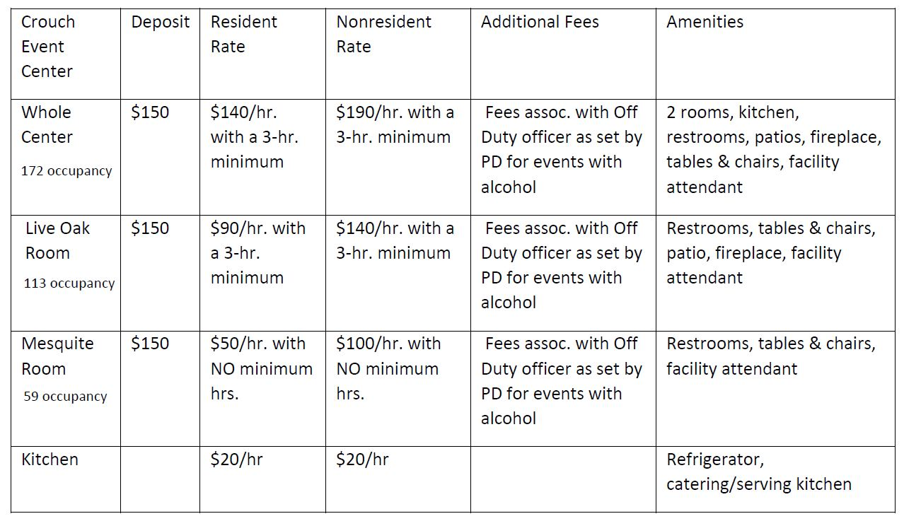

Approved September 2020 by CMO

IV. Rental Cancellations
- Users who must cancel a reservation will have the option of rebooking their event. If the reservation cannot be rescheduled, the contract holder is subject to the following:
- Rentals cancelled 45 calendar days or more prior to scheduled event will receive 100% of the deposit.
- Rentals cancelled 44-15 calendar days prior to scheduled event will receive 50% of the deposit.
- Rentals cancelled 14 calendar days or less prior to the scheduled event will forfeit all the deposit.

V. Facility Use
- User agrees to indemnify and hold harmless the City, its agents, and employees from and against any claims for damages to persons or property arising out of any use of the Crouch Event Center and premises by user. The user does hereby assume all liability and responsibility for bodily injuries, claims, or suits for damages to persons or property of whatsoever kind or character, whether real or asserted, occurring in connection with the use of the Crouch Event Center or premises by user, his or her agents, servants, employees, contractors or subcontractors. The City assumes no responsibility for any personal property placed in or about the facility.
- User agrees to leave the premises in as good or better condition than which existed prior to their usage. Please refer to the Facility Cleaning Checklist. All trash must be properly disposed of in the outside dumpster. All tables and chairs shall be cleaned off by the user. All decorations must be removed. If the food preparation area is used, all utensils and appliances must be cleaned, spills mopped up, scuffmarks removed, and floors shall be swept.
- User agrees to assume all responsibility for any damages done to the premises because of their usage, even above the deposit amount. An authorized Recreation Department representative shall have two business days following an event to determine and assess any damages done to the premises. It shall be the responsibility of the Center staff to notify user of any damages during this two-day period. User shall assume repair and/or replacement costs based on the Director’s assessment.
- No verbal agreements for use of the Crouch Event Center shall be valid. All reservations must be made through the Crowley Recreation Center and confirmed with a written contract, signed, and approved by Center staff and the user fees paid with the deposit. The deposit is due the day of the reservation and the remaining balance must be paid within ten days of the scheduled event.
- User shall comply with all federal, state, and local laws including all ordinances of the City of Crowley and all rules, regulations and requirements of the Parks and Recreation, Police and Fire Departments.
- User shall not schedule an event, which will have a larger attendance than the posted occupancy capacity of the reserved area.
- User shall not collect fees in the Crouch Event Center or the area surrounding the facility unless approval has been granted in writing by an authorized representative of the Recreation Department. All reservations where monies are collected are subject to approval by the Director. The City will only consider organizations that are an organized civic, cultural, and/or service group, or state or nationally chartered as a nonprofit organization with membership open to all Crowley residents.
- User must not attempt to gain access to the Crouch Event Center before the reservation time and must vacate the premises at the end of the reservation. The time specified on the contract is the time that Center staff will abide by. If the reservation extends beyond the designated time, additional rental charges will be assessed in half-hour increments. The user will be expected to monitor their rental without having to be told by staff that time has expired.
- A three-hour minimum is required for all rentals at the Crouch Event center except for the small room.
- Access to the large patio and fireplace will be included with the following rentals: Live Oak Room or Whole Facility. It is not included in the rental of the Mesquite Room. Fireplace Parameters have been established for the use of the fireplace to ensure a pleasant and safe experience for all.
  - Only clean/dry wood should be burned in the fireplace. Wood is not provided.
  - No trash, yard waste or other materials shall be burned.
  - The smoke from the fireplace shall not become a nuisance and interfere with others ability to enjoy the park or Crouch Event Center. If so, the fire shall be extinguished immediately.
  - User should make themselves aware of the location of the fire extinguisher(s) or other methods of fire control and ensure that they are readily available prior to starting a fire.
  - The fireplace shall always be supervised by a responsible adult.
  - The fire must be completely extinguished before the fire is left unattended.
  - In the event of a burn ban, the fireplace will be unavailable.
- Access to the back patio is included in the rental of the Mesquite Room.
- The kitchen is available for rental on a first come, first serve basis, and must be reserved for the entirety of the rental.
- User shall use only the areas, which are specified in the reservation agreement. User shall not do or permit to be done, in or upon any portion of the Center or its premises, anything that will obstruct or interfere with the rights of the other Users of the facility.
- User shall not sub-lease or assign its reservation to another individual, group, or organization.
- The contract holder must check in with the attendant and complete the walkthrough process prior to setup for the event. A final walkthrough will be completed with the contract holder prior to vacating the premises at the end of the reservation. This walkthrough includes the kitchen, food preparation areas, restrooms, and outdoor spaces.
- A limited number of chairs and tables shall be available for use by the User. The Live Oak room has access to 10 round tables, 6 rectangular tables, and 96 chairs. The Mesquite room has access to 4 round tables, 4 rectangular tables, and 40 chairs. Center staff is responsible for setting up and taking down tables and chairs and returning them to their proper storage locations. User may, at their own risk and expense, provide their own tables and chairs, which must be set up and taken down by the User. All supplies and equipment provided by the User must be removed from the center at the end of the reservation period or the User will forfeit deposit and future rental opportunities.
- The Crouch Event Center may be used for political activities if, and only if, the event is not involved with fundraising. Political literature and other printed or recorded material may not be distributed to other facility users. The political activity must remain within the reserved area and not impede on others ability to use the building, park facilities or parking lots.
VI. Eligibility for Use of Facilities
- Reservations will be accepted from persons 21 years of age or older.
- Groups or individuals shall be given equal opportunity regardless of race, color, national origin, sex, religion, age, or disability status.
- An adult chaperone is required for every 20 guests under 21 years of age. Chaperones must be present at the facility before it is opened for the event and remain throughout the entire function.

VII. Requirements
- Persons requesting a reservation will complete and submit a Crouch Event Center Rental Application form at least 14 days prior to the requested rental date. The completed application must be returned to the Crowley Recreation Center, 405 S. Oak St., with the deposit. The application is then approved after it has been determined that the activity and other requests are suitable for the area being requested.
- A security deposit is required on all rentals. Upon completion of the rental, if the User has remained in compliance with their Center Use Agreement, the deposit will be refunded. Refund is subject to any remaining balances due on household.
- Deposits paid with cash will be refunded by check from the City of Crowley Finance Department. Allow 7 to 10 business days for refund processing and mailing.
- Deposits paid with credit card will be refunded back to the same credit card if the system allows it. User must present the credit card at Recreation Center to process refund.
- Remaining balance on the reservation must be paid in full ten days prior to the event. Events will be subject to cancellation and the deposit will not be refunded if the remaining balance is not paid.
VIII. Decorations
- User shall not be permitted to nail, tack, screw or otherwise physically attach materials to any part of the Crouch Event Center. This includes attaching tape to any painted surface.
- Confetti, glitter, and sidewalk chalk is prohibited.
- Fog, smoke, and bubble machines are prohibited within the Crouch Event Center.
- All decorative materials must be treated with flame proofing and must meet the City of Crowley Fire Codes. No candle burning or open flames are permitted.
- All decorations must remain within the reserved area.
- No additional time for decorating or cleanup is expressed or implied. These activities must be completed during the reservation period.
- User requiring services or equipment other than that normally provided by the Crouch Event Center shall be furnished by the user and subject to the Manager’s approval. User agrees to assume all necessary expenses incurred.
IX. Entertainment
- The Crouch Event Center is a family friendly facility located in Bicentennial Park. Parameters have been put in place to ensure that entertainment provided during rentals does not interfere with other users’ ability to use the park or event center. Appropriate music is allowed during rental events unless staff determines that it is offensive, explicit, or excessively loud. Center management will have the final decision as to the appropriateness.
- Disc jockeys, string quartets and bands will be allowed during the rental. User must notify the Recreation Manager at least ten days prior to the event with a list of vendors involved with the entertainment.
X. Alcoholic Beverages & Tobacco Use
- Rentals involving alcohol require the presence of an off-duty police officer. The User is responsible for all fees associated with this cost. The applicant shall contact Crowley Police Department’s Off-Duty Coordinator to coordinate a CPD officer for the event, at the hourly off-duty rate approved by the City.
- If the Crowley Police Department is unable to schedule a COPD officer, the Off-Duty Coordinator will provide the applicant with an authorized list of approved jurisdictions authorized to work off-duty at City events or facilities. Applicants may not bypass the above process.
- Alcoholic beverages are not authorized in Bicentennial Park. (City of Crowley Ordinance Sec. 58-56.6 Conduct of persons within park) Alcohol must remain in the authorized area at the Crouch Event Center. The officer must be scheduled for the entirety of the reservation. Violation of these provisions shall result in the shutdown of the event, forfeiture of the deposit and rental fees and prevent future rentals.
- Smoking, vaping, and the use of other tobacco products are permitted only in designated areas at Bicentennial Park.
XI. Youth Events
- Youth events are defined as those that have a primary participation base of attendees ages 13-20. All youth events require security arranged through the Crowley Police Department and approved by the Recreation Manager 14 business days prior to the event. The Recreation Department and Crowley Police Department will determine event security requirements. All fees and charges are the responsibility of the contract holder.
XII. Security
- Staff shall reserve the right to determine whether security shall be required during a scheduled event and, in collaboration with the Crowley Police Department, determine the level of security required.
- User is responsible for all expenses related to security. If User refuses to assume the cost of such police security, then the reservation shall be subject to cancellation and forfeiture of deposit.
- Youth events (dances, parties, celebrations, or similar events) may require additional security and control measures.
- Security is required for all rentals involving alcohol. Refer to section B for more information.
XIII. Conflicts and Exclusions
- The Recreation Department reserves the right to refuse or cancel any rental request should the event present a conflict with the Mission of the Parks and Recreation Department or the City of Crowley.
- The Recreation Department reserves the right to cancel a rental request upon violation of the facility use policies. Rental fees and security deposits could face forfeiture and refusal of any future rentals depending on the nature of the violation(s).
- The City reserves the right to refuse service to any guests or individual(s) exhibiting offensive or unacceptable behavior.
- Rental of space within the Crouch Event Center does not infer exclusive use of the entire facility. The exception to this is if the User has rented the entire facility for their private event.
- Facility use rules and regulations are established to protect users, staff, and city property.
XIV. Misrepresentation
- The City of Crowley reserves the right to withhold a portion or all the security deposit or rental fees. City staff may shut down an event if the contract holder has misrepresented information on the facility use agreement or other documentation as part of the rental agreement.
- Examples of misrepresentation include but are not limited to:
  - Failure to disclose the true nature of the activity or sponsor
  - Failure to arrange adequate security
  - Exceeding space capacity or the number of participants agreed to on the rental contract
  - Selling of merchandise and/or services without a permit
  - Charging admission fees without a permit
  - Serving alcohol without an off-duty officer present
-Approved September 2020 by CMO

I have read and understand the rules and regulations governing the City of Crowley’s Crouch Event Center reservations. Renter also understand that the rules, regulations, and fees are subject to change without notice, as they are approved by City Council. Any changes, deletions or revisions to this agreement must be made in person and approved by all parties.

Signature of Renter:____________________________ Date:_______________

Printed Name:______________________________

